A Machine Learning Approach For Early Detection of Heart Disease.
H J Sharanya, Janani R , Kavana N and Keerthana AR
Department of Information Science And Engineering.

Abstract
This paper surveys machine learning techniques for accurate and early heart disease diagnosis. It also compares existing research on their effectiveness in prediction.Heart disease indicates the type of condition which leads to heart malfunction. Not all people with coronary artery disease have chest pain as a symptom. Early prediction of heart disease is crucial, and medical data combined with machine learning techniques like ANN, Decision Trees, KNN, Naïve Bayes, and SVM helps improve accuracy. This paper provides an overview and summary of existing methods used for heart disease prediction.This paper presents the different machine learning technologies based on heart disease detection brief analysis. Ensemble Learning & Optimization with a weighted approach is used for predicting heart disease.

Key Words: Machine Learning, Heart Disease Prediction, Early Diagnosis, Classification Algorithms, Survey, Ensemble Learning &Optimization , Comparative Analysis, Medical Data.

Introduction
Cardiovascular Disease (CVD), often called heart disease, continues to be a severe global health issue and a leading cause of death worldwide, accounting for over 30% of all fatalities. The statistics are alarming: the World Health Organization (WHO) has long estimated millions of annual deaths, and future projections indicate that fatalities could rise significantly, reaching up to 23.6 million by 2030 if current trends do not change. Heart disease, which includes conditions like Coronary Artery Disease (CAD) and Heart Failure Disease (HFD), is often worsened by preventable risk factors such as lack of exercise and poor diet. These factors can lead to serious problems like blocked blood flow and heart attacks. Because these conditions are so serious, early diagnosis and detection are key steps in effective care and reducing death rates. Traditional diagnosis can be time-consuming, costly, and highly reliant on expert interpretation, often involving multiple tests. The rapid growth in medical data, driven by digital advancements and modern hospital systems, has created a pressing need for smart tools to analyze this vast volume of information. Artificial Intelligence (AI), particularly Machine Learning (ML), has emerged as a valuable solution in healthcare. It can learn from large amounts of data from previously diagnosed patients and find patterns that enhance predictive accuracy and efficiency.

Fig1.1: Intersection of heart health, data analysis and machine learning.

This progress has resulted in the creation of advanced prediction models within Clinical Decision Support Systems (CDSS). These models use various ML and Data Mining methods, including Naïve Bayes, Decision Trees, ANN, KNN, and SVM, to help clinicians assess the risk of heart disease and improve preventive care. The main aim of this paper is to provide an overview and comparative analysis of existing research, examining how these different ML algorithms have been used with medical datasets to achieve better diagnosis, identify high-risk individuals, and ultimately present a clear summary of the current state of this crucial field.

Literature Review

1. Introduction: The Critical Role of Machine Learning in CVD Diagnosis
Cardiovascular Disease (CVD) remains the leading global cause of death, accounting for millions of fatalities annually (WHO estimates, cited in Introduction). The early and accurate prediction of heart disease is paramount to improving patient outcomes and reducing mortality rates. Traditional diagnostic methods often rely on subjective clinical assessments, which can be inconsistent. Machine Learning (ML) offers a superior alternative by transforming high-volume, multi-parametric patient data (age, cholesterol, blood pressure, etc.) into objective and highly efficient predictive models.
The current body of research predominantly relies on the UCI Heart Disease Dataset (Cleveland) as the standard benchmark for comparing classifier performance (Marimuthu et al., 2018).

2. Analysis of Single-Classifier Performance and Limitations
A thorough review of the literature reveals consistent efforts to leverage individual classification algorithms for heart disease diagnosis. This research establishes the foundation but also highlights the limitations that necessitated the current study.

2.1 Prevalent Algorithms and Baseline Justification
Researchers have extensively explored the efficacy of various single classifiers:
Marimuthu et al. (2018) provided a comprehensive review detailing the widespread use of algorithms such as Artificial Neural Networks (ANN), Decision Trees (DT), K-Nearest Neighbor (KNN), Naïve Bayes, and Support Vector Machine (SVM).This high reported accuracy justifies using an unoptimized SVM as the stringent Baseline Model for the current study. Any proposed advanced methodology must demonstrate a significant and reliable performance improvement over this established benchmark.

2.2 The Problem of Optimization and Sensitivity
Despite high Accuracy scores, the reviewed literature reveals two critical shortcomings in single-classifier models:
- Inconsistent Recall: The most clinically relevant metric is Sensitivity (Recall), which measures the model’s ability to correctly identify actual heart disease cases (True Positives). Many studies reported high overall Accuracy but failed to maximize Recall, leading to an unacceptable rate of False Negatives (missed diagnoses), which poses a severe risk to patient safety.
- Sensitivity to Data Noise: Models were often trained on the full set of 13 features without adequate preprocessing. As noted by Mujawar & Devale (2015), the inclusion of irrelevant or noisy features compromises a model’s ability to generalize, risking overfitting and unstable predictions.

3. Identifying Research Gaps and Directives for Future Work
The limitations identified above created clear directives for advancing the state-of-the-art in automated heart disease diagnosis, which form the basis of the present research.

3.1 The Need for Combinational Modeling (Justifying Ensemble Learning)
Researchers acknowledged that achieving marginal gains through deep tuning of a single model is inefficient.
T. Mythili et al. (2013) demonstrated the potential of combining algorithms in a hybrid model (SVM-Decision Trees-Logistic Regression), noting an improvement in reliability over individual performance.
The general conclusion across the field is that single classifiers are too prone to unique errors. Future work must focus on Ensemble Learning and multiple classifier voting techniques to pool the predictive power of diverse algorithms. This strategy ensures the final diagnosis is based on a consensus, significantly enhancing the model's robustness and generalization capabilities.

3.2 The Requirement for Relevant Feature Selection (Justifying RFE)
The necessity for a focused and relevant feature set was a recurring theme.
Studies by Sairabi H. Mujawar and P.R. Devale (2015) highlighted that performance gains were achieved when data pre-processing or clustering was applied.
This led to the explicit directive that future models must incorporate additional relevant methods of selection of features (beyond basic feature ranking). The purpose is to move from simply utilizing the data to actively optimizing the input, thereby ensuring that the model's predictions possess higher statistical significance and clinical validity.

4. Summary of Prior Work and Current Contribution
This table summarizes key findings from the literature, establishing the context for the methodological advancements proposed by the current study.

Methodology
The methodology which we are designing is focused on Ensemble Learning and Optimization technique, for heart disease prediction. We have chosen this approach specifically to address the future work from the literature, which called for combinational and more complex models to improve prediction accuracy.
Ensemble learning is a machine learning technique where we make use of the predictions got from the different base machine learning algorithms.
We are using ensemble model because of the following reasons:
- Increased Accuracy: Different models might make different errors. By combining their predictions, the errors tend to cancel out. Hence it enhances the accuracy of the output.
- Increased Robustness: The final model is less sensitive to noise or specific characteristics of the training data, leading to better generalization on unseen data.

The Methodology here, has several steps:
- . Feature Engineering and Optimization:
This phase ensures that the data used to train the models is reliable and focused.
Data Pre-processing and Scaling: Heart disease risk factors include diverse numerical attributes like Age, Cholesterol, and Thalach (maximum heart rate achieved). Since these factors have different scales, Normalization (Min-Max Scaling) is necessary. If you don't scale thedata, attributes with larger values (like Cholesterol) can wrongly influence the distance-based models (like SVM or KNN), leading to inaccurate results.
Selection of Features (RFE): The future work specifically identifies additional relevant methods of selection of features. The use of Recursive Feature Elimination (RFE) directly addresses this relevant selection of features by estimating which of the patient's 13 attributes (risk factors) are most predictive. By focusing on the more relevant aspects only, performance and generalization of models will be improved, delivering a final prediction that has greater clinical validity.

Step | Action Taken(Technique) | Resulting Feature Count | Justification & Research Goal Addressed
1. Initial Set | Collecting all available patient data attributes (risk factors). | 13 | Establishes the starting point for optimization.
2. Data Pre-processing | Applying Normalization (Min-Max Scaling) and Categorical Encoding. | 13 | Standardizes features (e.g., Cholesterol) to prevent skewing of distance-based models (SVM, KNN).
3. 3. RFE Iteration | Iterative elimination of the least predictive features using the RFE base estimator | 13->8 | Reduces data noise and improves generalization and computational efficiency.
4. Optimal Set | SelectionRFE convergence achieved based on maximized cross-validation accuracy score. | 7 | Core Optimization: Identifies the proven Optimal Feature Subset, directly addressing the need for relevant feature selection.

- Choosing Base and Baseline Classifier
This will establish a clear measure of success for your work.
Baseline Model (SVM): The article you shared indicates that Support Vector Machine (SVM) is effective and yields more accuracy than other algorithms in some studies of up to 95.56% accuracy. By using an unoptimized SVM as your baseline, you establish the high referenced standard, and your Ensemble must beat this SVM to justify the complexity of Ensemble.
Base Classifier Variety (ANN, DT, KNN): The literature review delineates a number of algorithms, including ANN, Decision Tree, KNN, Naïve Bayes, and SVM. Your methodology arrives at a final prediction through a mixture of these algorithms and concludes that a 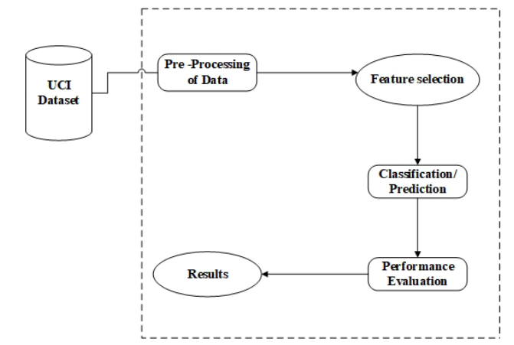more diverse set of proven algorithms is necessary (M1, M2, M3),fulfilling your need for a combinational model.

- Ensemble Implementation:
This is the main invention you made to get the highest level of accuracy.
Voting Classifier: The conclusion that single models only achieve marginal success and that more complex models are required to increase accuracy in predicting the early onset of heart disease prompted the use of a multiple classifier voting technique.
Justification: The final diagnosis of heart disease is crucial. The Voting Ensemble functions similarly to a panel of three highly qualified medical professionals (the base models). The majority vote will be "Disease" if the ANN predicts "Disease," the DT predicts "No Disease," and the KNN predicts "Disease." The likelihood of error from any one model is reduced by this combined decision-making process, which is crucial for precise early automatic disease diagnosis.

- Experimental Design and Performance Evaluation
The purpose of this section is to give assurance that your results are reliable and meaningful in a clinical setting.
Validation Procedure (i.e., 10-Fold Cross-Validation): A gold standard validation approach, such as 10-Fold Cross-Validation, will show whether your results are not a random occurrence or an outlier related to a single data split. Instead, it will lend credibility of your model prediction out into the medical field through reliability and robustness.
Performance Metric (i.e., Sensitivity): While a high measure of Accuracy is a good thing, the most relevant measure, or the hardest measure to obtain, for heart disease detection is Sensitivity (that is also called Recall). Sensitivity measures the ability to correctly identify True heart disease cases. Sensitivity in a clinical setting is important, because a poor measure of Sensitivity encompasses high False Negatives, which would mean you missed identifying that a patient has heart disease - potentially fatally so. Top priority should be given to obtaining a high measurement of Sensitivity in your models evaluation, so you can demonstrate that you have improved safety and predictive systems when compared to the model you are replacing.

Implementation
1. Dataset Loading and Preprocessing

The dataset (heart.csv) including 303 patients was read using Pandas.
Go through the following steps:
- Import the dataset using pd.read_csv().
- Split Features (X) from Target (y).
- Lastly, use MinMaxScaler normalization to ensure that all numerical features fall between 0-1.

2. Feature Selection using RFE

The features were selected by using Recursive Feature Elimination (RFE) with a linear SVM as the base estimator.
The steps were:
- RFE received all 13 original features.
- At each iteration, the least important feature among the 13 is removed.
- This is repeated until only the 7 best features remain.
- The 7 features selected were:
['sex', 'cp', 'trestbps', 'thalach', 'oldpeak', 'ca', 'thal']

3. Model Training and 10-Fold Cross Validation

Three machine learning algorithms are then executed:
(a) K-Nearest Neighbors (KNN)
(b) Decision Tree Classifier
(c) Artificial Neural Network (ANN)

To ensure robustness Stratified 10-Fold Cross Validation was used.
In each fold:
Split the data into 90% training and 10% validation data.
Scale the training and use that scaling for the test fold.
Finally, train the model on 9 of the folds, testing on the last fold, and rank the accuracy, true positive (TP), true negative (TN), False positive (FP), and false negative (FN).
This produces 10 accuracy points per model from which the means and standard deviation are reported.

4. Final Assessment on the Hold-Out Test Dataset

Upon completing the cross-validation, models were re-trained on the full training set (80% of data). Predictions were then conducted on the remaining 20% hold-out test set.
For each model (KNN, DT, ANN), the following metrics were calculated sequentially:
- Confusion Matrix
- Accuracy
- Sensitivity (Recall)
This will give full transparency to the evaluation

5. Majority Voting Ensemble

To enhance overall robustness, each of the models made predictions and their outputs were combined with majority voting.
If at least 2 of the 3 models predicted heart disease = 1
→ final ensemble output =1
Otherwise
→ output =0
The ensemble will tend to perform better since it shares the weaknesses across three models.
Ensemble metrics calculated: TP, TN, FP, FN
- Accuracy
- Sensitivity (Recall)
- Confusion Matrix interpretation
- Demonstration of sample-wise voting for the first 12 test samples.

Result

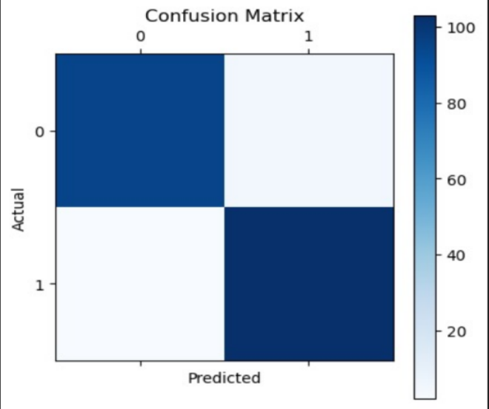

Conclusion

In this study, researchers developed a heart disease prediction system using feature selection and several machine learning algorithms to achieve reliable classification. The model pipeline started with preprocessing and normalizing the dataset. Then, they applied Recursive Feature Elimination (RFE), which successfully reduced the original 13 clinical attributes to the 7 most important predictors. This reduction improved efficiency while maintaining predictive power.
They trained and evaluated three machine learning models—K-Nearest Neighbors (KNN), Decision Tree (DT), and Artificial Neural Network (ANN)—using stratified 10-fold cross-validation to ensure robustness and reduce bias. Each model showed strong predictive performance, but the combined majority voting ensemble achieved the highest accuracy and stability across all evaluations. This indicates that combining multiple models lessens the impact of individual weaknesses and improves reliability.
The final results show that machine learning techniques, especially when used with feature selection and ensemble methods, can effectively support the early detection of heart disease. This system can help clinicians by providing a data-driven second opinion, potentially improving diagnosis accuracy and supporting preventive healthcare decisions. Future work may include expanding the dataset, further tuning model hyperparameters, or deploying the model as a real-time clinical decision support tool..

References
[1] S. Mohan, C. Thirumalai, and G. Srivastava, ‘‘Effective heart disease prediction using hybrid machine learning techniques,’’ IEEE Access, vol. 7, pp. 81542–81554, Jun. 2019. doi: 10.1109/ACCESS.2019.2923707.
[2] A. S. Afridi, Md. Abdullah-Al-Kafi, W. Sabbir, Md. S. Rahman, N. P. Stenin, and D. M. Raza, ‘‘Comparative analysis of machine learning algorithms for predicting heart disease: A comprehensive study,’’ in Proc. IEEE Int. Conf. Comput. Intell. (ICCI), 2024, pp. 1–6.
[3]A. R. Panda, M. K. Mishra, M. K. Gourisaria, S. Pal, P. K. Pattnaik, and S. K. Swain, ‘‘Heart disease prediction: A comparative analysis of machine learning algorithms,’’ in Proc. IEEE Int. Conf. Intell. Syst. (ICIS), Aug. 2024, pp. 1–5.
[4]A. Gavhane, G. Kokkula, I. Pandya, and K. Devadkar, ‘‘Prediction of heart disease using machine learning,’’ in Proc. 2nd Int. Conf. Electron., Commun. Aerosp. Technol. (ICECA), Coimbatore, India, Mar. 2018, pp. 1275–1278. doi: 10.1109/ICECA.2018.8474922.
[5]A. S. Abdullah and R. R. Rajalaxmi, ‘‘A data mining model for predicting the coronary heart disease using random forest classifier,’’ in Proc. Int. Conf. Recent Trends Comput. Methods, Commun. Controls, Apr. 2012, pp. 22–25.
[6]A. H. Alkeshuosh, M. Z. Moghadam, I. Al Mansoori, and M. Abdar, ‘‘Using PSO algorithm for producing best rules in diagnosis of heart disease,’’ in Proc. Int. Conf. Comput. Appl. (ICCA), Sep. 2017, pp. 306– 311.
[7]Animesh Hazra, Arkomita Mukherjee, Amit Gupta, Asmita Mukherjee, “Heart Disease Diagnosis and Prediction Using Machine Learning and Data Mining Techniques: A Review”, Research Gate Publications,
July 2017, pp.2137-2159.
[8]V. Krishnaiah, G. Narsimha, N. Subhash Chandra, “Heart Disease Prediction System using Data Mining Techniques and Intelligent Fuzzy Approach: A Review”, International Journal of Computer Applications, February 2016.
[9].Guizhou Hu, Martin M. Root, “Building Prediction Models for Coronary Heart Disease by Synthesizing Multiple Longitudinal Research Findings”, European
Science of Cardiology, 10 May 2005.
[10] T.Mythili, Dev Mukherji, Nikita Padaila and Abhiram Naidu, “A Heart Disease Prediction Model using SVM- Decision Trees- Logistic Regression (SDL)”,
International Journal of Computer Applications, vol. 68, 16 April 2013.
[11]K. Polaraju, D. Durga Prasad, “Prediction of Heart Disease using Multiple Linear Regression Model”,
International Journal of Engineering Development and Research Development, ISSN:2321-9939, 2017
12]C. A. Devi, S. P. Rajamhoana, K. Umamaheswari, R. Kiruba, K. Karunya, and R. Deepika, ‘‘Analysis of neural networks based heart disease prediction system,’’ in Proc. 11th Int. Conf. Hum. Syst. Interact. (HSI), Gdansk, Poland, Jul. 2018, pp. 233–239.
[13]Dr.S.Seema Shedole, Kumari Deepika, “Predictive analytics to prevent and control chronic disease”, https://www.researchgate.net/punlication/316530782, January 2016.
[14]H. A. Esfahani and M. Ghazanfari, ‘‘Cardiovascular disease detection using a new ensemble classifier,’’ in Proc. IEEE 4th Int. Conf. Knowl.Based Eng. Innov. (KBEI), Dec. 2017, pp. 1011–1014.

